SNAKE AND LADDER Problem

As a game developer, I want to develop a smarter version of SNAKE-&-LADDER game. I want to define the game as below

a 10X12 board with 7 snakes and 7 ladders

Snake will bring you down. Ladder will climb you up.

I shall allow 2 players at time.

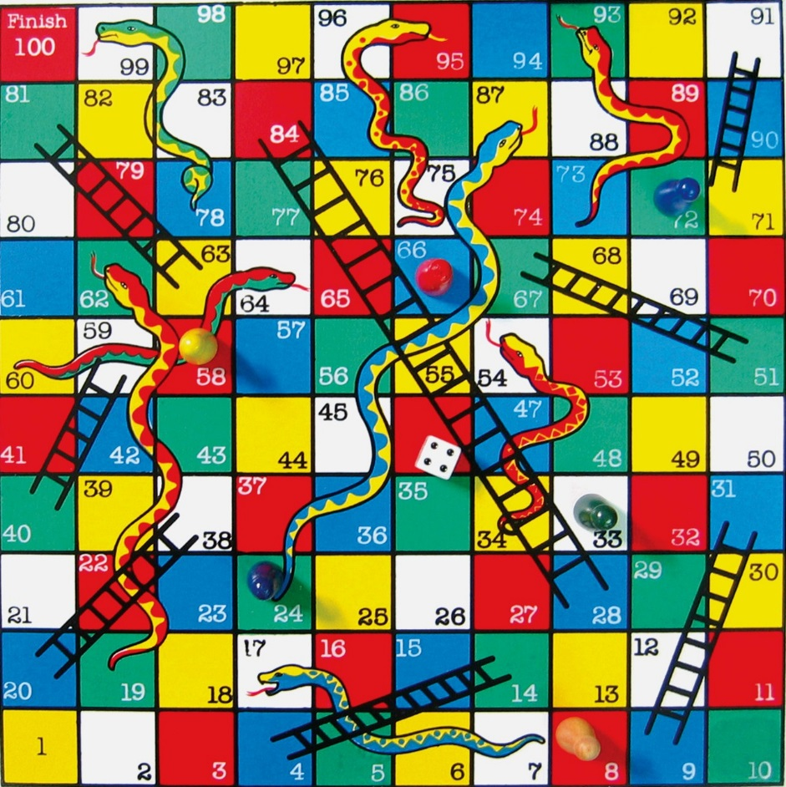

Tech Expectations:

* Should be in Java
* Provide as many logic as possible
* Use Git hub to get the initial project.
* Fork your project using Git
* Make your changes
* Check in using forked version.
* Project available at <https://github.com/PrafullaGirgaonkar/Ladder>